T1
CheckBoxFrame.java
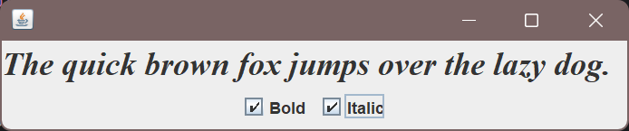
package ink.abalone.week14.T1;

import javax.swing.*;
import java.awt.*;
import java.awt.event.ActionListener;

public class CheckBoxFrame extends JFrame {
private JLabel label;
private JCheckBox bold;
private JCheckBox italic;
private static final int FONTSIZE = 24;
public CheckBoxFrame() {
label = new JLabel("The quick brown fox jumps over the lazy dog.");
label.setFont(new Font("Serif",Font.BOLD,FONTSIZE));
add(label,BorderLayout.CENTER);
ActionListener listener = e->{
int mode = 0;
if (bold.isSelected()) mode +=Font.BOLD;
if (italic.isSelected()) mode +=Font.ITALIC;
label.setFont(new Font("Serif",mode,FONTSIZE));
};
var buttonPanel = new JPanel();
bold = new JCheckBox("Bold");
bold.addActionListener(listener);
bold.setSelected(true);
buttonPanel.add(bold);
italic = new JCheckBox("Italic");
italic.addActionListener(listener);
buttonPanel.add(italic);
add(buttonPanel,BorderLayout.SOUTH);
pack();
}

public static void main(String[] args) {
new CheckBoxFrame().setVisible(true);
}
}

TextComponentFrame.java
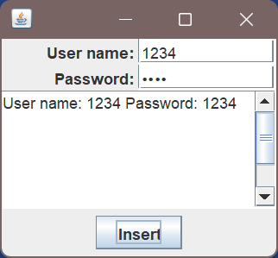
public class TextComponentFrame extends JFrame {
public static final int TEXTAREA_ROWS = 8;
public static final int TEXTAREA_COLUMNS = 8;
public TextComponentFrame(){
var textField = new JTextField();
var passwordField = new JPasswordField();
var northPanel = new JPanel();
northPanel.setLayout(new GridLayout(2,2));
northPanel.add(new JLabel("User name: ",SwingConstants.RIGHT));
northPanel.add(textField);
northPanel.add(new JLabel("Password: ",SwingConstants.RIGHT));
northPanel.add(passwordField);
add(northPanel, BorderLayout.NORTH);
var textArea = new JTextArea(TEXTAREA_ROWS, TEXTAREA_COLUMNS);
var scrollPane = new JScrollPane(textArea);
add(scrollPane, BorderLayout.CENTER);
var southPanel = new JPanel();
var insertButton = new JButton("Insert");
southPanel.add(insertButton);
insertButton.addActionListener(e->{
textArea.append("User name: "+textField.getText()+" Password: "+new String(passwordField.getPassword())+"\n");
});
add(southPanel, BorderLayout.SOUTH);
pack();
}
public static void main(String[] args) {
new TextComponentFrame().setVisible(true);
}
}
T2
CalculatorPanel.java
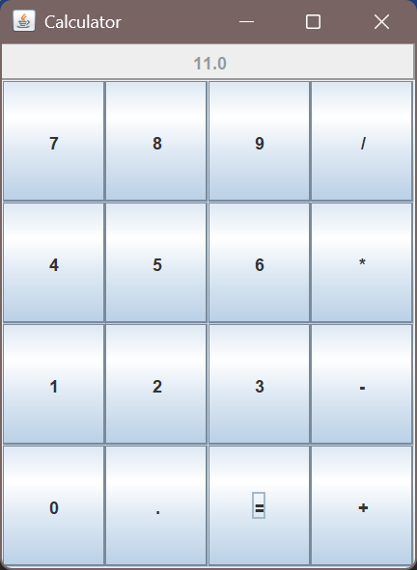
package ink.abalone.week14.T2;
import javax.swing.*;
import java.awt.*;
import java.awt.event.ActionEvent;
import java.awt.event.ActionListener;
public class CalculatorPanel extends JPanel {
private JButton display;
private JPanel panel;
private double result;
private String lastCommand;
private boolean start;
private String currentInput; // 当前输入的数字字符串
public CalculatorPanel() {
setLayout(new BorderLayout());
result = 0;
lastCommand = "=";
start = true;
currentInput = ""; // 初始化当前输入为空
display = new JButton("0");
display.setEnabled(false);
add(display, BorderLayout.NORTH);
var insert = new InsertAction();
var command = new CommandAction();
panel = new JPanel();
panel.setLayout(new GridLayout(4,4));
char[] c = {'7','8','9','/','4','5','6','*','1','2','3','-','0','.','=','+'};
for (char c1 : c) {
if (c1 != '/' && c1 != '*' && c1 != '-' && c1 != '.' && c1 != '=' && c1 != '+') addButton(c1 + "", insert);
else addButton(c1+"", command);
}
add(panel, BorderLayout.CENTER);
}
private void addButton(String label, ActionListener listener) {
var button = new JButton(label);
button.addActionListener(listener);
panel.add(button);
}
private class InsertAction implements ActionListener {
@Override
public void actionPerformed(ActionEvent e) {
String input = e.getActionCommand();
if (start) {
currentInput = input;
start = false;
} else currentInput += input;
display.setText(currentInput);
}
}
private class CommandAction implements ActionListener {
@Override
public void actionPerformed(ActionEvent e) {
String command = e.getActionCommand();
if (!start) {
try {
double currentValue = Double.parseDouble(currentInput);
calculate(currentValue);
} catch (NumberFormatException ex) {
display.setText("Error");
start = true;
return;
}
start = true;
}
lastCommand = command;
if (command.equals("=")) {
result = 0;
lastCommand = "=";
}
}
}
public void calculate(double x) {
switch (lastCommand) {
case "+" -> result = result + x;
case "-" -> result = result - x;
case "*" -> result = result * x;
case "/" -> {
if (x == 0) {
// 处理除零错误
display.setText("Error: Div by 0");
result = 0;
lastCommand = "=";
start = true;
return;
} else {
result = result / x;
}
}
case "=" -> result = x;
}
display.setText(String.valueOf(result));
}
public static void main(String[] args) {
JFrame frame = new JFrame("Calculator");
frame.setSize(300, 400);
frame.setDefaultCloseOperation(WindowConstants.EXIT_ON_CLOSE);
frame.add(new CalculatorPanel());
frame.setVisible(true);
}
}

T3
RegisterFrame.java
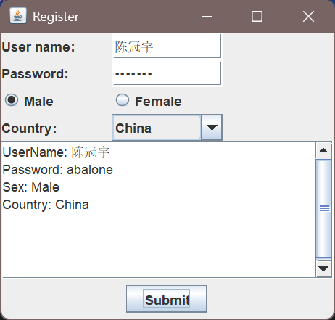
package ink.abalone.week14.T3;
import javax.swing.*;
import java.awt.*;
import java.awt.event.ActionEvent;
import java.awt.event.ActionListener;
public class RegisterFrame extends JFrame {
private static final int TEXTAREA_ROWS = 8;
private static final int TEXTAREA_COLUMNS = 30;
public Dimension getPreferredSize() {
return new Dimension(320,300);
}
private JTextField textField;
private JPasswordField passwordField;
private JRadioButton male;
private JRadioButton female;
private JComboBox<String> comboBox;
private JTextArea textArea;
private void accountInit(JPanel northPanel){
textField = new JTextField();
passwordField = new JPasswordField();
northPanel.add(new JLabel("User name: "));
northPanel.add(textField);
northPanel.add(new JLabel());
northPanel.add(new JLabel("Password: "));
northPanel.add(passwordField);
northPanel.add(new JLabel());
}
private void sexInit(JPanel northPanel){
ButtonGroup group = new ButtonGroup();
male = new JRadioButton("Male",true);
female = new JRadioButton("Female",false);
group.add(male);
group.add(female);
northPanel.add(male);
northPanel.add(female);
northPanel.add(new JLabel());
}
private void comboBoxInit(JPanel northPanel){
northPanel.add(new JLabel("Country: "));
String[] countries = {"China", "USA", "India","Japan","England"};
comboBox = new JComboBox<>(countries);
northPanel.add(comboBox);
}
private void showAreaInit(){
textArea = new JTextArea(TEXTAREA_ROWS, TEXTAREA_COLUMNS);
var scrollPane = new JScrollPane(textArea);
add(scrollPane, BorderLayout.CENTER);
textArea.setEditable(false);
}
private void submitInit(JPanel southPanel){
JButton submit = new JButton("Submit");
southPanel.add(submit);
submit.addActionListener(e -> {
String userName = textField.getText();
String password = new String(passwordField.getPassword());
String selectedSex = male.isSelected() ? "Male" : "Female";
String selectedCountry = (String) comboBox.getSelectedItem();
String userInfo = String.format(
"UserName: %s\nPassword: %s\nSex: %s\nCountry: %s",
userName, password, selectedSex, selectedCountry);
textArea.setText(userInfo);
});
}
public RegisterFrame(){
setTitle("Register");
var northPanel = new JPanel();
northPanel.setLayout(new GridLayout(4,3));
accountInit(northPanel);
sexInit(northPanel);
comboBoxInit(northPanel);
add(northPanel,BorderLayout.NORTH);
showAreaInit();
var southPanel = new JPanel();
submitInit(southPanel);
add(southPanel,BorderLayout.SOUTH);
pack();
}
public static void main(String[] args) {
JFrame frame = new RegisterFrame();
frame.setDefaultCloseOperation(JFrame.EXIT_ON_CLOSE);
frame.setVisible(true);
}
}

T4
BreakoutPanel.java
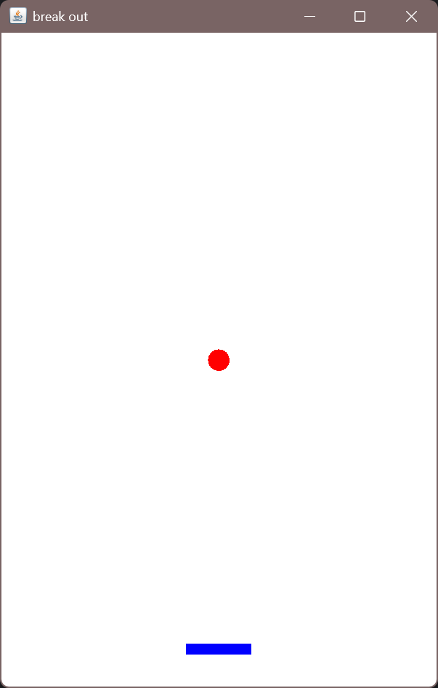
package ink.abalone.week14.T4;
import java.awt.Color;
import java.awt.Dimension;
import java.awt.Graphics;
import java.awt.Point;
import java.awt.event.ActionEvent;
import java.awt.event.ActionListener;
import java.awt.event.MouseEvent;
import java.awt.event.MouseMotionListener;
import java.util.Random;
import javax.swing.ImageIcon;
import javax.swing.JPanel;
import javax.swing.Timer;
public class BreakoutPanel extends JPanel {
/** Width and height of application window in pixels */
public static final int APPLICATION_WIDTH = 400;
public static final int APPLICATION_HEIGHT = 600;
/** Dimensions of game board (usually the same) */
private static final int WIDTH = APPLICATION_WIDTH;
private static final int HEIGHT = APPLICATION_HEIGHT;
/** Dimensions of the paddle */
private static final int PADDLE_WIDTH = 60;
private static final int PADDLE_HEIGHT = 10;
/** Offset of the paddle up from the bottom */
private static final int PADDLE_Y_OFFSET = 30;
/** The coordinate of the ball*/
private int ballX,ballY;
/** Radius of the ball in pixels */
private static final int BALL_RADIUS = 10;
/** The coordinate of the paddle*/
private int paddleX,paddleY;
/** Constructor */
public BreakoutPanel(){
//paddle最开始时，横坐标位于窗口的中间位置，纵坐标离窗口底端PADDLE_Y_OFFSET。paddleX,paddleY分别代表paddle左上角坐标
ballX = APPLICATION_WIDTH / 2 - BALL_RADIUS;
ballY = APPLICATION_HEIGHT / 2 - BALL_RADIUS;
//球最开始时，在窗口的中间位置，ballx,bally分别代表球所在正方形的左上角坐标
paddleX = (APPLICATION_WIDTH - PADDLE_WIDTH) / 2;
paddleY = APPLICATION_HEIGHT - PADDLE_Y_OFFSET - PADDLE_HEIGHT;
setPreferredSize(new Dimension(APPLICATION_WIDTH, APPLICATION_HEIGHT));
setBackground(Color.white);
}
public void paintComponent(Graphics page){
super.paintComponent(page);
drawBall(page);
drawPaddle(page);
}
//根据ballx,bally,BALL_RADIUS,画球
private void drawBall(Graphics page){
page.setColor(Color.RED);
page.fillOval(ballX, ballY, BALL_RADIUS * 2, BALL_RADIUS * 2);
}
// 根据paddleX,paddleY,PADDLE_WIDTH,PADDLE_HEIGHT,画paddle
private void drawPaddle(Graphics page){
page.setColor(Color.BLUE);
page.fillRect(paddleX, paddleY, PADDLE_WIDTH, PADDLE_HEIGHT);
}
}

